Form No.: Motorsport UK / SRVIF /



Category 2

Stage Rally Vehicle Identity Form

This form is intended solely for competition use and is no guarantee of the vehicle’s authenticity.
It is not to be used for commercial purposes or as proof of the vehicle’s history.

Make: |  |  |  |  | Model:
Chassis no. / vin: |  |  |  |  | Registration no.:
Year of original manufacture: |  |  |  |  | Engine capacity: |  |  | cc
Motorsport UK vehicle passport no.: |  |  |  |  | Forced induction corrected capacity: |  |  |  |  | cc

Section 1: Record of eligibility checks

This section will be used should a problem arise from scrutineering or with the eligibility of a car at an event.

Date | Venue/Event | Remarks | Name/Status of Official

This section to be completed by Motorsport UK:

We Motorsport UK, have inspected the details on these pages and to the best of our knowledge consider the car to be correctly described and categorised:
Signed: |  |  | Date:
Status of signatory:

Note: This form is only valid where presented alongside the corresponding Motorsport UK Vehicle Passport. Should the car be entered for an event and found not to conform to this form, the Organiser will return it along with the corresponding Vehicle Passport, stating the reason, to the Motorsport UK.

THIS FORM REMAINS THE PROPERTY OF MOTORSPORT UK

Each page of this form must bear the stamp of Motorsport UK

Form No.: Motorsport UK / SRVIF /
¾ Front:  from right side | 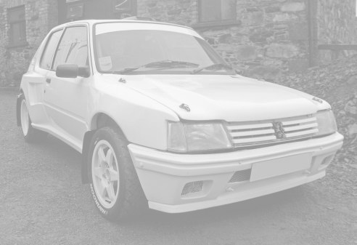
¾ Rear:  from left side | 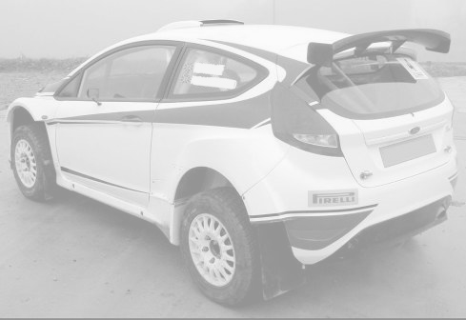
Front suspension / brake side view:  (wheel removed) | 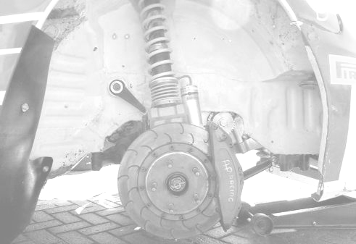

Form No.: Motorsport UK / SRVIF /
Front suspension / brake ¾ view:  with steering on full lock  to show spring, strut,  shock absorber &  brake caliper  (wheel removed) | 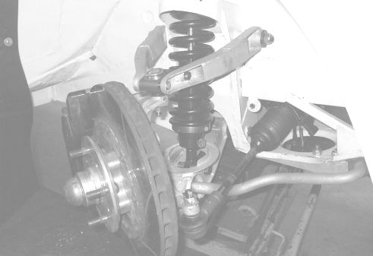
Rear suspension: showing spring, strut,  shock absorber &  brake caliper | 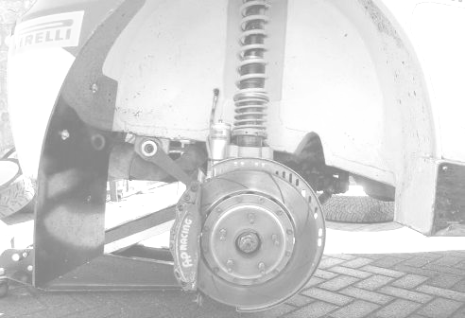
Front bulkhead:  (bare shell) | 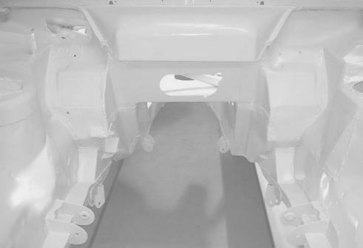

Form No.: Motorsport UK / SRVIF /
Interior of  passenger compartment:  looking rearward to  show rear wheel arches/suspension  mounts and rear bulkhead/luggage compartment/floor  (bare shell) | 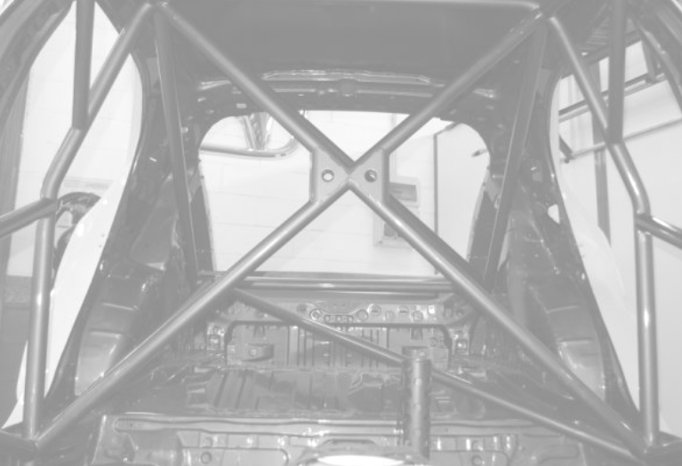
Transmission  Tunnel:  (bare shell) | 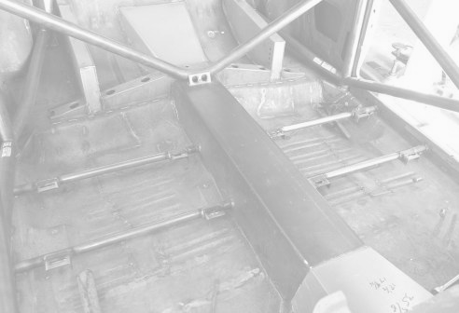
Interior of  luggage  compartment:  from outside  (bare shell) | 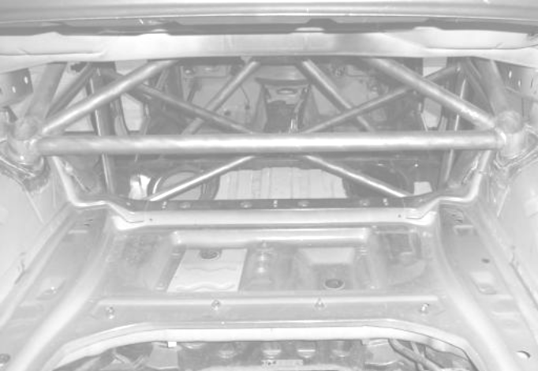

Form No.: Motorsport UK / SRVIF /
Dashboard:  from driver’s seat | 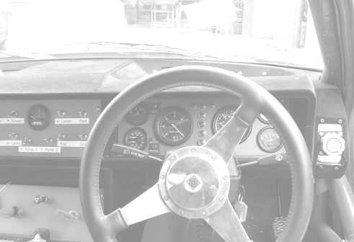
ROPS:  through driver’s door | 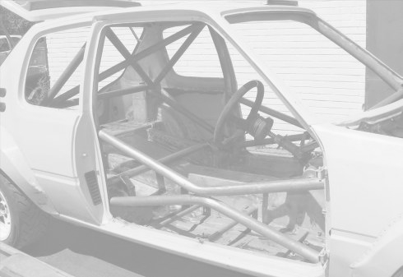
ROPS:  through rear window | 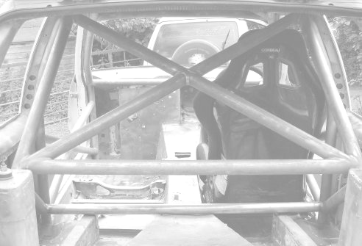

Form No.: Motorsport UK / SRVIF /
Engine:  from right | 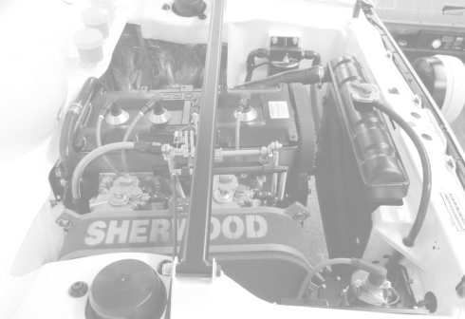
Engine:  from left | 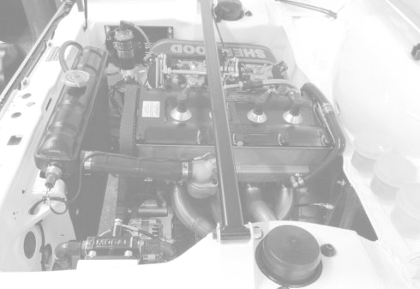
Complete  engine bay:  from front or rear | 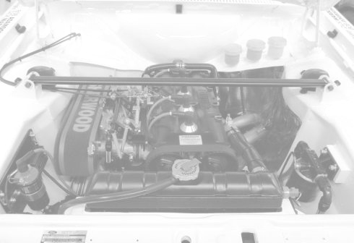

Form No.: Motorsport UK / SRVIF /

Section 2: Chassis
2.1 Chassis/Bodyshell
(a) How is chassis/bodyshell identified & where?
(b) Construction: (unitary, space frame, monocoque etc.)
(c) Material:
(d) Is chassis/bodyshell original to this vehicle? |  |  |  |  |  |  | *
(e) If no, state when, why and by whom new chassis/bodyshell was constructed:
(1) When constructed:
(2) Details of constructer:
(f) Is chassis/bodyshell to vehicle manufacturer’s original specification? |  |  |  |  |  |  |  | *
(g) If no, state any non-original features:
(h) Details & location of other I.D. numbers on chassis/bodyshell: (special build no., build date etc.)

2.2 Transmission tunnel (where applicable)

(a) Confirm the dimensions for the points marked ‘a’ to ‘q’ respectively:
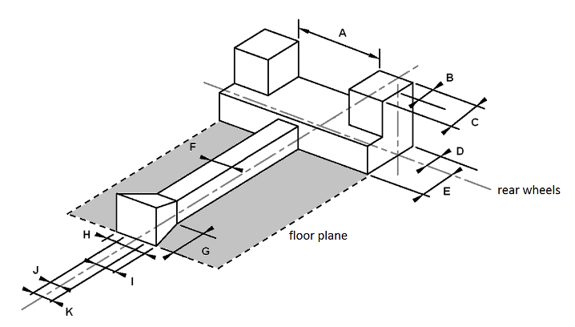

* Delete as applicable

Form No.: Motorsport UK / SRVIF /

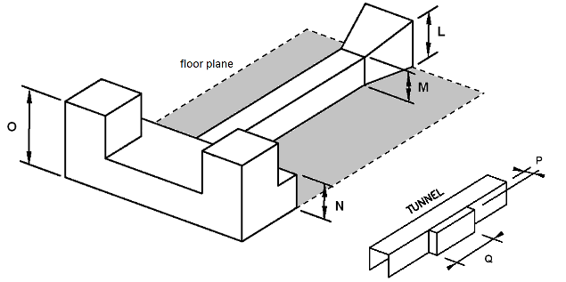

A: |  | mm | J: |  | mm
B: |  | mm | K: |  | mm
C: |  | mm | L: |  | mm
D: |  | mm | M: |  | mm
E: |  | mm | N: |  | mm
F: |  | mm | O: |  | mm
G: |  | mm | P: |  | mm
H: |  | mm | Q: |  | mm
I: |  | mm

(b) Confirm the link box aperture dimensions for the points marked r & s for each side:

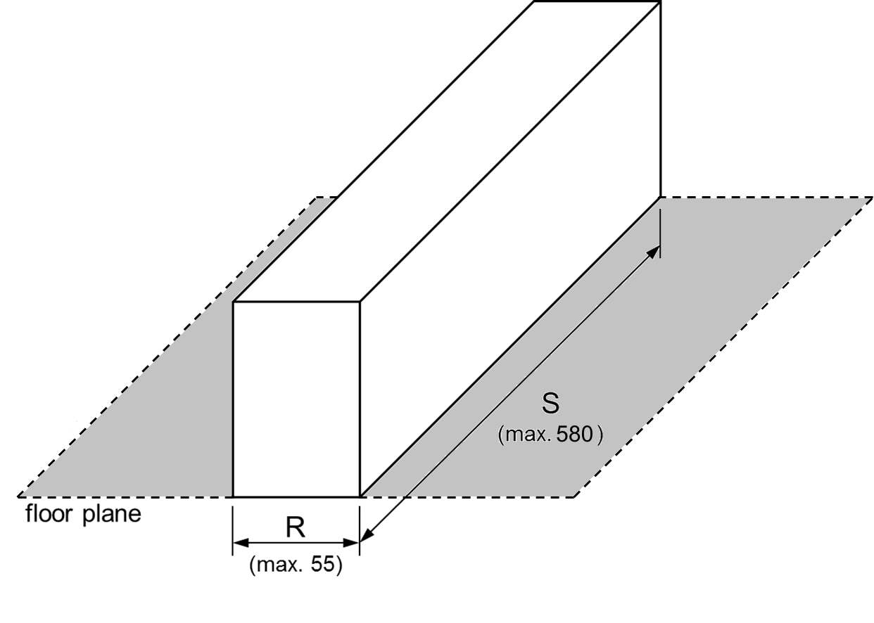

Nearside: |  |  | Offside:
R: |  | mm | R: |  | mm
S: |  | mm | S: |  | mm

Form No.: Motorsport UK / SRVIF /

2.3 Bodywork
(a) Type: (e.g. saloon) |  |  |  | (b) Material: |  |  |  |  | (c) No. of doors
(d) Are all body panels to original specification? (shape, material, location etc.) |  |  |  |  |  |  |  |  |  | *
(e) If no, state changes:
(f) Are any additional panels fitted? (wheel arch extensions etc.) |  |  |  |  |  |  | *
(g) If yes, describe: (include homologation number etc. where applicable)
(h) Is the bodywork original to the chassis? |  |  |  |  | *
(i) If no, state changes:

2.4 Front suspension
(a) Suspension type: (MacPherson strut, wishbone etc.)
(b) Spring type: (coil, leaf etc.)
(c) Dampers: |  | Number: |  |  |  |  |  | Type: (lever, telescopic etc.)
(d) Is suspension to original specification & dimensions? (including joints) |  |  |  |  |  |  |  |  |  |  |  | *
(e) If no, state deviations from original:
(f) Is suspension adjustable? |  |  |  |  | *
(g) If yes, state method: (rose joints, adjustable platforms etc.)
(h) Is anti-roll bar fitted? |  |  |  | * |  |  |  |  | (i) If yes, is it adjustable? |  |  |  |  | *

2.5 Rear suspension
(a) Suspension type: (MacPherson strut, wishbone, trailing arm etc.)
(b) Spring type: (coil, leaf etc.)
(c) Dampers: |  | Number: |  |  |  |  |  | Type: (lever, telescopic etc.)
(d) Is suspension to original specification & dimensions? (including joints) |  |  |  |  |  |  |  |  |  |  |  | *
(e) If no, state deviations from original:
(f) Is suspension adjustable? |  |  |  |  | *
(g) If yes, state method: (rose joints, adjustable platforms etc.)
(h) Is anti-roll bar fitted? |  |  |  | * |  |  |  |  | (i) If yes, is it adjustable? |  |  |  |  | *

* Delete as applicable

Form No.: Motorsport UK / SRVIF /

Section 3: Engine
3.1 Engine
(a) Is engine original specified fitment to vehicle? |  |  |  |  |  |  |  | *
(b) Original manufacturer: |  |  |  |  |  |  |  |  |  | (c) Engine no.:
(d) Year of manufacture: |  |  |  |  |  |  | (e) Cycle: |  |  | *
(f) Number of cylinders: |  |  |  |  |  |  | (g) Config.: (straight, vee etc.)
(h) Bore: |  |  | mm |  |  | (i) Stroke: |  |  | mm |  | (j) Capacity: |  |  |  |  | cc
(k) No. of camshafts: |  |  |  |  |  |  | (l) No. of valves per cylinder:
(m) Is engine in original location & orientation for this vehicle make & model? |  |  |  |  |  |  |  |  |  |  |  | *
(n) If no, state modifications:

3.2 Fuel system
(a) Is fuel tank to original specification & location? |  |  |  | *
(b) If no, state changes:
(c) Type of fuel: (eg. petrol, diesel etc.)

3.3 Fuel feed
(a) Fuel feed: | *
(b) If forced induction: |  | Make: |  | Type:

Section 4: Transmission
4.1 Gearbox
(a) Make: |  |  |  | (b) Type:
(c) Number of forward speeds:
(d) Is gearbox standard to this make & model of vehicle? |  |  |  |  | *
(e) Gear selection: (sequential, H-pattern etc.)

4.2 Final drive
(a) Wheels driven: |  | *
(b) Method of drive: (shaft, chain)
(c) Is a limited slip or torque-biasing differential fitted? |  |  |  | *
(d) If yes, specify what make and method of operation:

* Delete as applicable

Form No.: Motorsport UK / SRVIF /

Section 5: Brakes & steering
5.1 Brakes
(a) Make: | Front: |  |  |  |  |  | Rear: |  |  |  |  |  |  |  |  |  | Other:
(b) Type: | Front: |  |  |  |  |  | Rear: |  |  |  |  |  |  |  |  |  | Other:
(c) Method of operation:
(d) Disc type: (solid, ventilated, cross-drilled, grooved) |  |  |  |  |  |  |  |  |  |  | Front: |  |  |  |  |  |  |  | Rear:
(e) Disc material:
(f) Caliper manufacturer & type: (AP Racing, 4-piston etc.) |  |  |  |  |  |  |  |  |  |  |  |  | Front:
 |  |  |  |  |  |  |  |  |  |  |  |  | Rear:
(g) Braking system: |  |  |  | *
(h) Is the brake bias adjustable? |  |  |  |  |  | *
(i) If yes, is it by balance bar, pressure limiter or both?
(j) Can bias be adjusted by driver or co-driver while normally seated? |  |  |  |  |  |  |  |  |  |  |  |  |  |  |  | *
(k) Parking brake: |  | Type: (cable, hydraulic)
 |  | Operation: (rear drum, caliper)
(l) Does the parking brake operate independently of the main braking system? |  |  |  |  |  |  |  |  |  |  |  |  |  |  |  |  |  | *

5.2 Steering
(a) Type: (rack & pinion, worm & peg etc.)
(b) Is steering to original specification? |  | * |  | (c) If no, state changes:

Section 6: Safety
6.1 Roll Over Protection System
(a) Manufacturer:
(b) Drawing/homologation No.:
(c) Method of attachment to bodyshell:
(d) Doorbar type: (double, crossed etc.)
(e) Dimensions: |  | NB: (unless homologated) Mandatory members minimum 45mm x 2.5mm or 50mm x 2.0mm  Optional members minimum 38mm x 2.5mm or 40mm x 2.0mm
 |  | Main Rollbar |  |  |  | Front/Lateral  Rollbar |  |  | Backstays |  | Main Rollbar  diagonal members
External Diameter |  |  |  | mm |  |  |  | mm |  | mm |  | mm
Wall Thickness |  |  |  | mm |  |  |  | mm |  | mm |  | mm

* Delete as applicable

Form No.: Motorsport UK / SRVIF /

6.2 Fire extinguisher (FIA-homologated)
(a) Make: |  |  |  |  | (b) Type:
(c) FIA homologation number: |  |  |  |  |  | (d) Expiry date:
(e) No. of nozzles & locations:
(f) Capacity:

6.3 Fuel cell (FIA-homologated)
(a) Make: |  |  | (b) Type:
(c) FIA homologation number: |  |  |  | (d) Expiry date:

Section 7: Weight & dimensions
7.1 Weight & dimensions
(a) Weight of vehicle: |  | kg |  |  |  | (b) Wheelbase: |  |  |  |  |  |  |  | mm
NB: Weight of vehicle is without fuel and without occupants and their associated personal safety equipment, but with all other vehicle safety equipment and with one spare wheel. Excludes all vehicle jacks, tools and similar equipment.
(c) Track: (between centres of tyre treads) |  |  |  | Front: |  |  |  | mm |  | Rear: |  |  |  |  | mm
(d) Overall width at axle line: |  |  | Front: |  |  |  | mm |  | Rear: |  |  |  | mm

* Delete as applicable

Form No.: Motorsport UK / SRVIF /

Section 8: Applicant’s declaration

I certify that the answers given by me in this form are correct and I undertake to notify the motor sports association in writing immediately should any changes be made. I also certify that any entry form for competition purposes will be filled in according to the information contained in this form.

Applicants name:
Address:
 |  |  |  |  |  |  |  | Postcode:
Licence number: (if applicable)
 Home: |  |  |  |  |  Mobile:
 Work: |  |  |  |  | Email:
Applicant’s signature: |  |  |  |  |  |  |  |  | Date:

Note: Should the vehicle change ownership, please enter details at the bottom of this page and forward the complete set of papers to Motorsport UK who will forward the papers to the new owner following amendment of the Motorsport UK database.

Section 9: Technical inspection

Date of inspection: |  |  |  | Location:
Name of technical inspector:
Motorsport UK licence number: |  |  |  | Signature:

Section 10: Change of owners list

On change of ownership, please provide details here and return the papers to the Motorsport UK to be updated.

Name | Address | Date of acquisition

Form No.: Motorsport UK / SRVIF /

Section 11: Record of amendments

For Motorsport UK use, record of official amendments issued for specification changes.

Date | Details of specification changes | Approved by

