Report Safeguarding Concerns
‘Never do nothing’
Safeguarding is everybody’s responsibility.

Please report all safeguarding or welfare concerns to (add club/championship name) Club/Championship (delete as required) Safeguarding Officer (CSO).

If you do not feel comfortable or are unable to report your concern to the CSO or you wish to access guidance please contact Motorsport UK’s Safeguarding team via the details at the bottom of this document.

Concerns that an individual maybe at risk of immediate harm must be reported to the police and then to Motorsport UK Safeguarding team so that they can assist the police as appropriate.
If you are not sure what to do, please call number at the bottom of this poster.
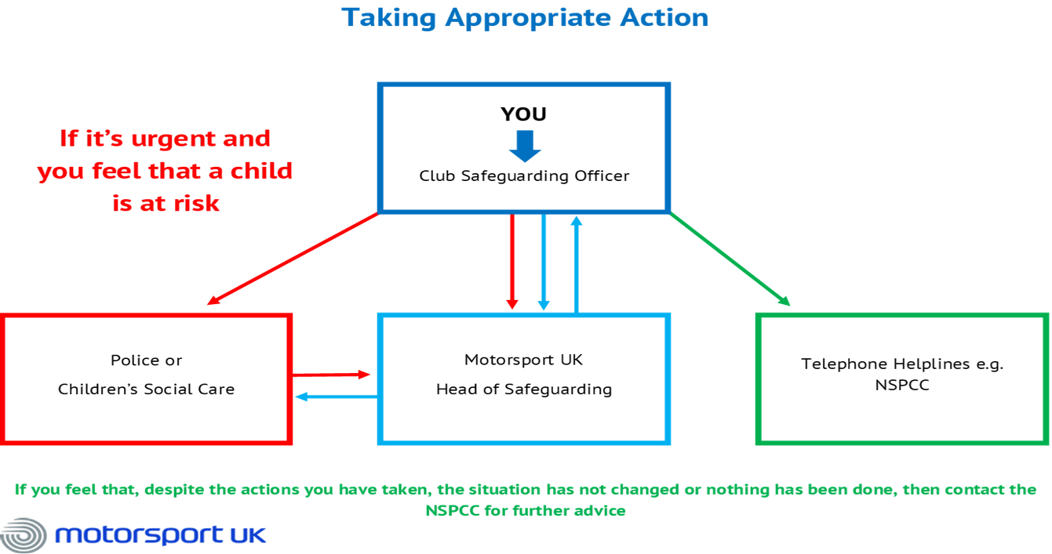

Motorsport UK Safeguarding Team: E: Safeguarding@motorsportuk.org

