Annex E - Stage Set Up Templates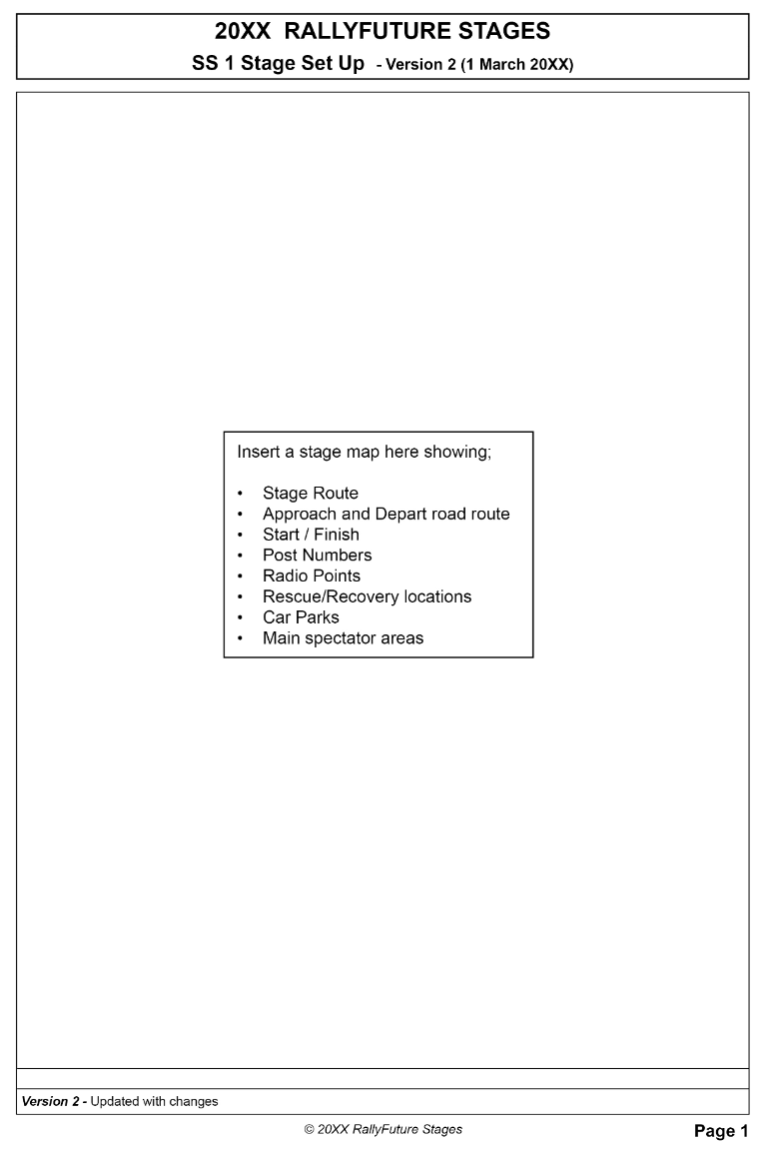 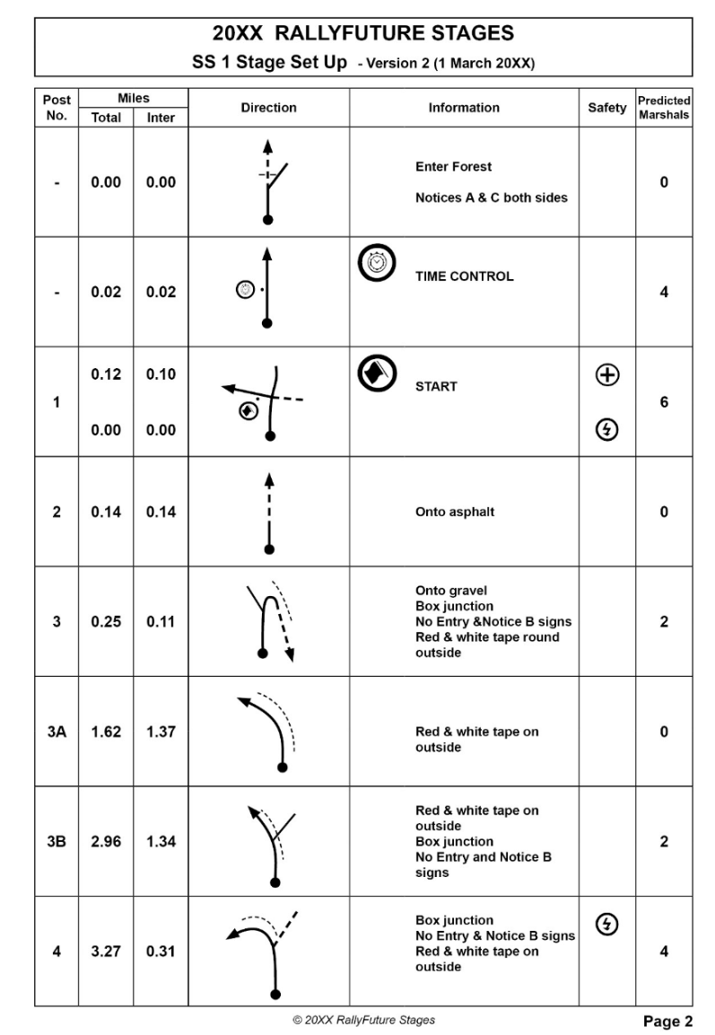
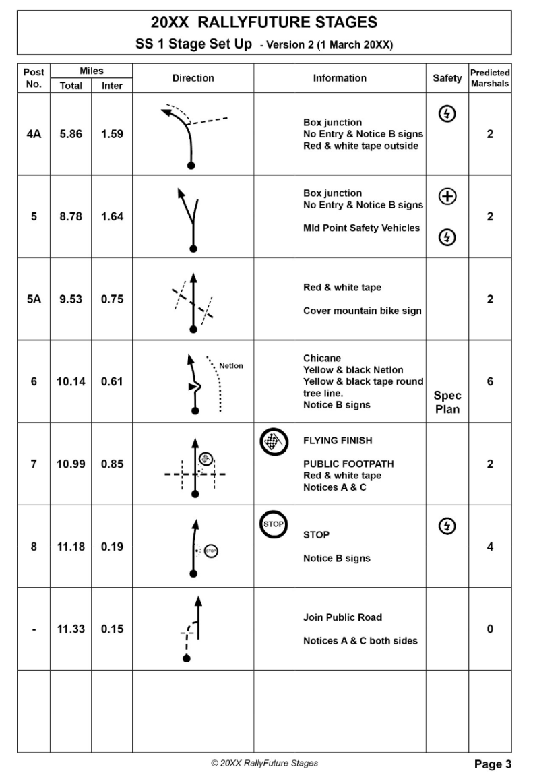

Post No. | Miles |  | Direction | Information | Safety | Predicted Marshals
 | Total | Inter

